MRKT 495 Strategic Marketing Management

Competitive Analysis Writing Assignment

Overview

Your job in this assignment is to pick a company and one of its products (can include all related product lines that focus on related target markets) that has significant competition for the same target markets. You will be looking for mature product categories that you think may still offer potential growth through strategic planning and focus on the marketing mix to find those product innovations and new market segments that would provide the companies with continued growth opportunities for the next several years in a competitive environment.

You will analyze the product in the context of its competitive environment and conclude competitive positions at this particular point in time, and regardless of whether your product is the leader, challenger, follower or nicher in the competitive arena if there is still sufficient opportunity to growth in the product category through strategic market planning.

Objectives

- Demonstrate appropriate use of financial and other quantifiable data in a competitive analysis

- Identify relevant market share data for a particular industry

- Conduct a competitive analysis of four companies in the same industry and subcategory

- Identify competitive positions of competitors in the same industry and subcategory

- Assess potential for any of the competitors to grow in the current stage of the product category.

Directions

- Review the readings on competitive analysis in the classroom resources.

2. Access the Hoovers database at the UMUC virtual library: umuc.edu/library

      - Sign into the UMUC Library
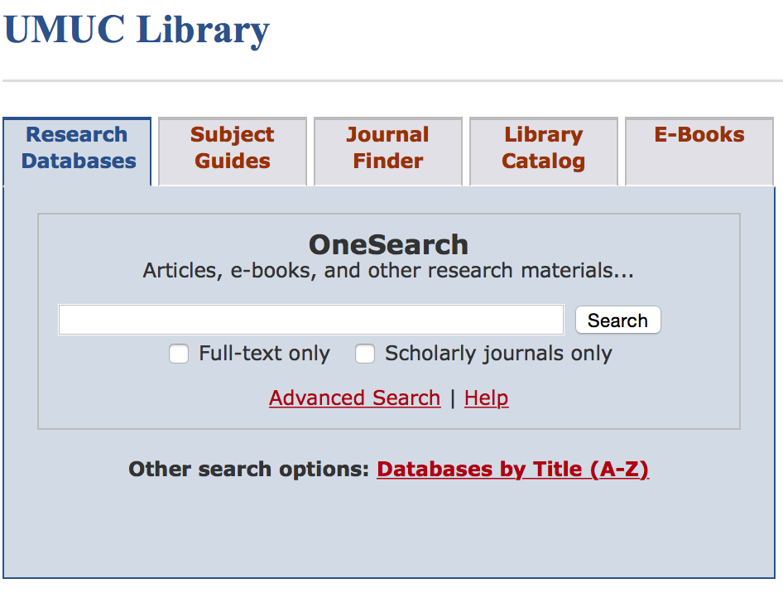
      - At the library homepage, click on ‘Databases by Title (A-Z)

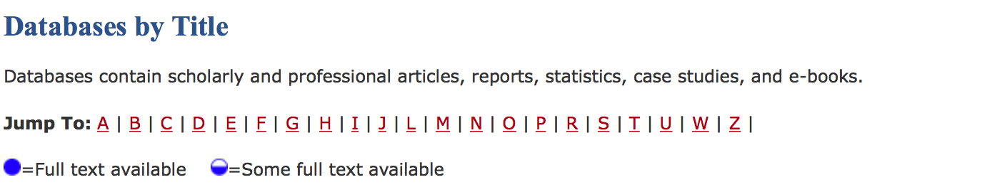
      - Click on the “H” in the alphabetic list

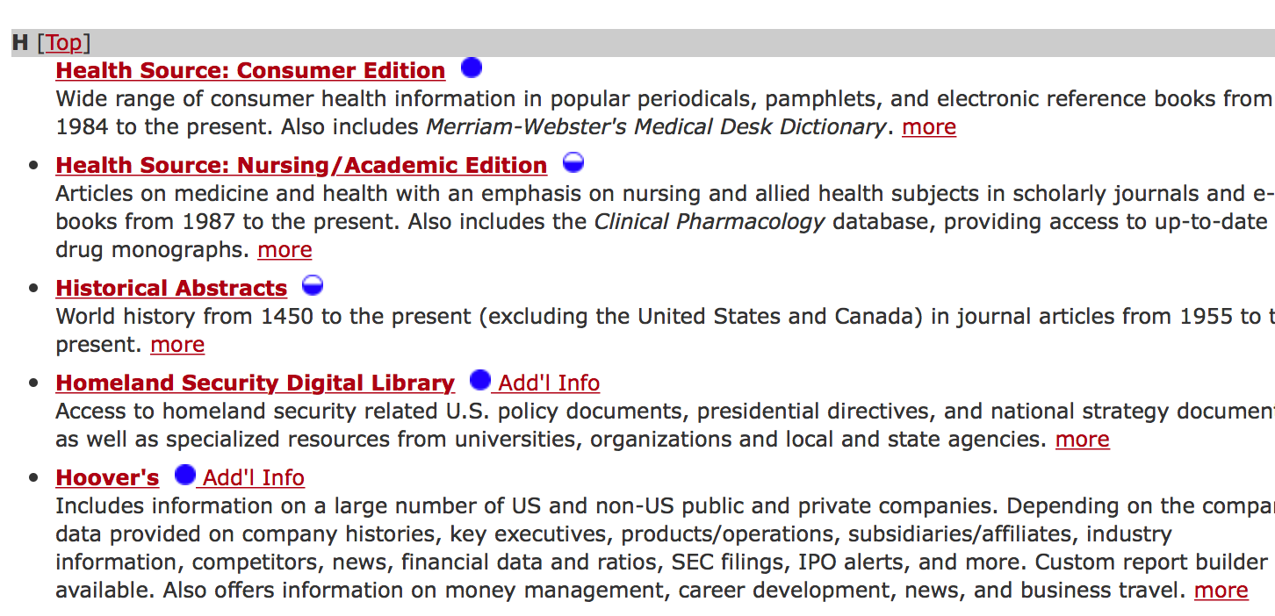
      - Scroll through the list of “H” databases until you see Hoovers.

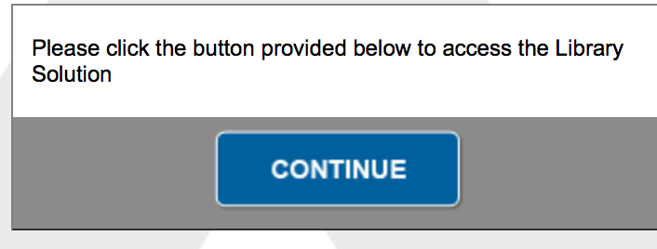
      - Click on “Continue” to gain access and begin your research.

Conduct your search of the Hoover’s database as follows:

- Identify an industry and subindustry categories and find list of all competitors in that subcategory.

- Find an industry category and a sub category to find companies that compete for the same customers. For example, you might pick “Arts, Entertainment and Recreation Sector”. Read the overview of the industry and note the industry leader. In this case scenario it is Comcast. Click on Comcast. Then click on “Competition”. Now you will see a list of all Comcast competitors such as Dish Network and Time Warner.

- Seek out an industry and subcategory you wish to explore. Identify the market leader as based on annual sales and three additional competitors. If your first choice of industry does not produce at least four competitors, look for another industry category.

- Scroll around the Hoover site for other valuable information such as the competitive landscape. Familiarize yourself as much as possible on the market leader and its competitors.

- Select one of the competitors that you think is in the best position to capture additional market share from the market leader by an aggressive marketing plan. Visit the websites of the market leader and the competitor you have selected for additional information.

If you need help at any time selecting a company to research please seek the advice and guidance of your faculty and classmates by posting in the Discussion Forum established for this purpose. All questions will be addressed by your faculty in the Discussion Forum and NOT via email.

Prepare your competitive analysis using the Competitive Analysis Worksheet Attached to this Assignment file.

List the competing companies down the left-hand side of the worksheet. Then, list at least four criteria for your analysis, e.g., annual sales, units sold, number of locations, pricing structure, etc., along the top. Some of this information is available on Hoovers, other pieces of information you will need to find in other sources. Suggest conducting a library search of your industry for some industry insight on the companies. Most industries have trade publications that frequently discuses market share and other important pieces of information about competitors and the competitive landscape.

Study your competitive analysis worksheet and then prepare your writing assignment by addressing each of the following questions in order:

- Who is the market leader? Why is that company the market leader? Specifically identify the data you found most relevant for defining a market leader (market share, annual sales, units sold, etc.)

- Who is the market challenger (next closest competitor)? Why is that company the market challenger? (Refer to the course content for definitions of these competitive categories.)

- Identify at least two other competitors and how you would categorize them, e.g., follower or niches. State your reasons for your selections.

- Which of the three non market leader competitors do you think has the best chance of taking a serious run at capturing additional market share from the market leader? Why do you think this is possible? Be as specific as possible.

Submission Requirements

Writing assignment must be prepared in a Word processed document and uploaded to your assignment folder.

Submissions should be no more than three pages of double-spaced type of no more than 12-point size.

In addition to the three pages of text, attach your completed competitive analysis worksheet and a list of properly cited references used in your analysis.

Be sure your assignment is free of typos or grammatical errors as this will negative affect your grade.

Submit your assignment no later than midnight on the due date as stated in the LEO calendar.

Faculty Assistance

Please use the Discussion Forum to ask your faculty member any questions or concerns you may have about this writing assignment any time before the due date. Your faculty can help you with the process of identifying companies and help you critically assess the information you have found. You are encouraged to seek faculty assistance early and as often as needed so that your submitted assignment represents your best effort at a meaningful competitive analysis.

Library Assistance

For any questions or concerns about the Hoover database, please contact a librarian via the link in the library’s website.

You can also access the following library tutorial on how to access and use the Hoover’s Database http://polaris.umuc.edu/library/BusinessResearch/list_of_companies

Grading Rubric

The following grading rubric will be used to assess your competitive analysis.

